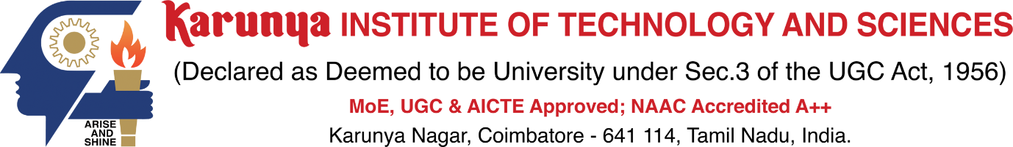

School of Computer Science and Technology

**Division of Artificial Intelligence and Machine Learning**

**SKILL-BASED ASSESSMENT – STUDENT SELECTION**

|  |  |  |  |  |  |
| --- | --- | --- | --- | --- | --- |
| Course Code & Name: | | |  | | |
| Name of the Course Teacher: | | |  | | |
| # | Team No. | Student Team Members | | | Identified Skills |
| Name of the Student | | Reg.No |
| 1 | Team - 1 | Student 1 | |  | * Programming Skills * Laboratory Proficiency   *(Just for sample only)* |
| Student 2 | |  |
| Student 3 | |  |
| 2 |  |  | |  |  |
| 3 |  |  | |  |  |
| 4 |  |  | |  |  |

|  |  |
| --- | --- |
| Prepared by  Signature of the Course Teacher | Approved by  Signature of the HoD |
|  |  |